Lab 7: ADC control using TIVA C

Register Description:

# RCGCO:pg-455

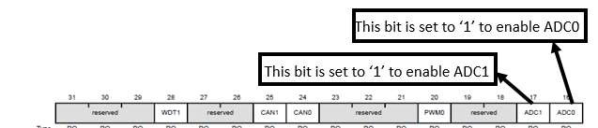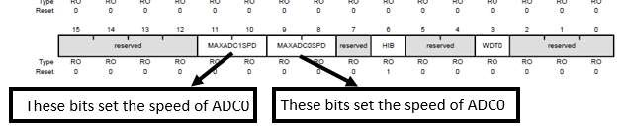

SSPRI:(pg-838) We use sequencer 3 as we capture just one sample at a time

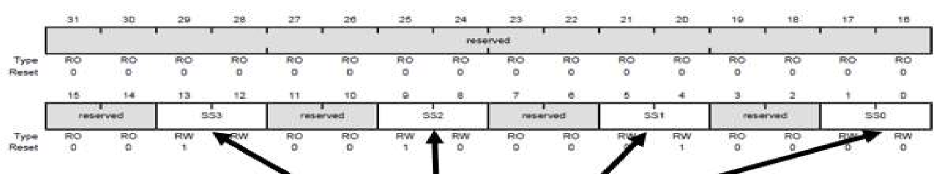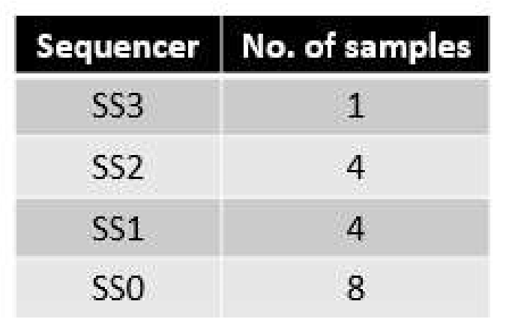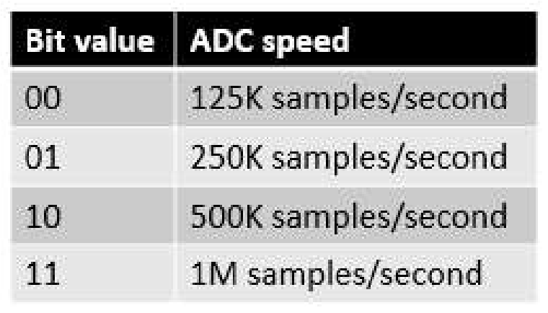

# ACTSS:pg-818

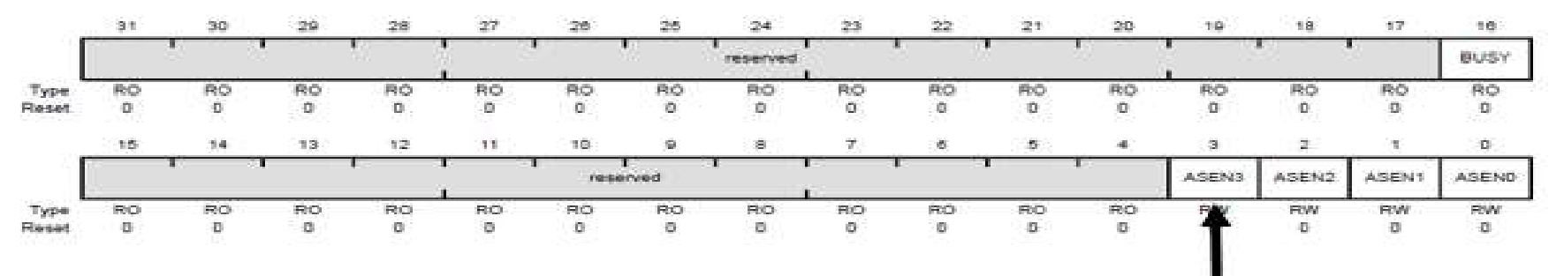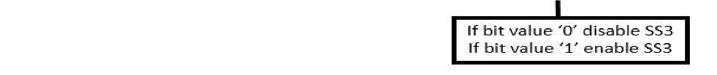

# EMUX:pg-830

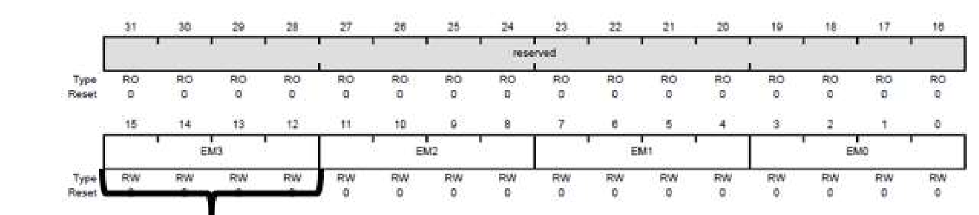

# SSMUX:pg-872

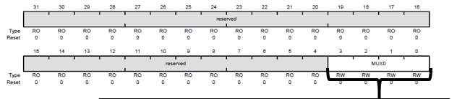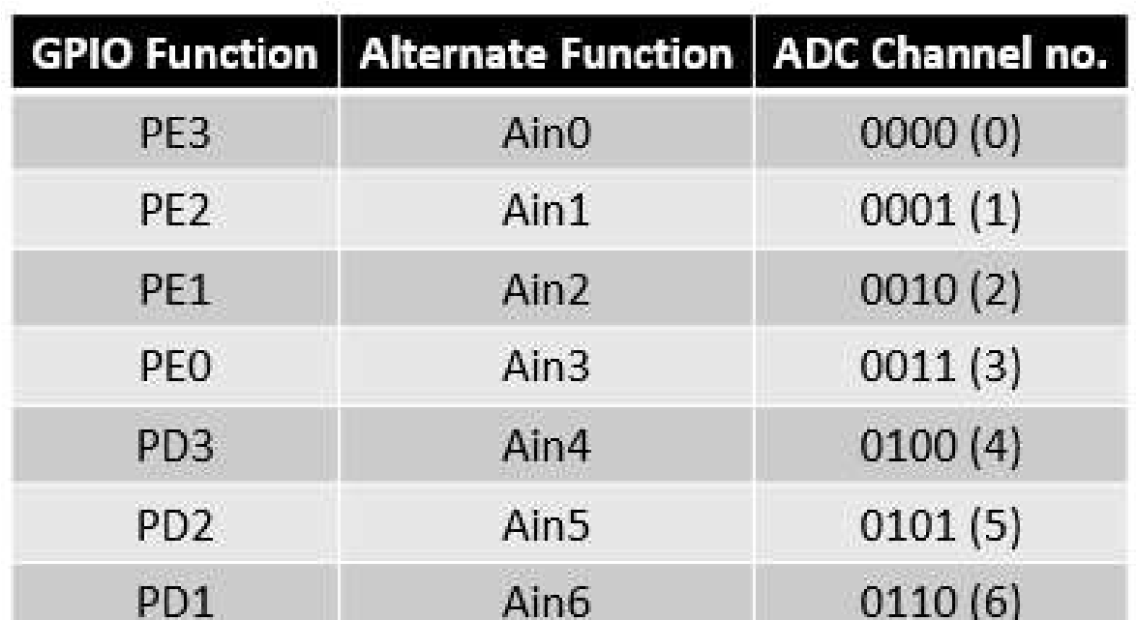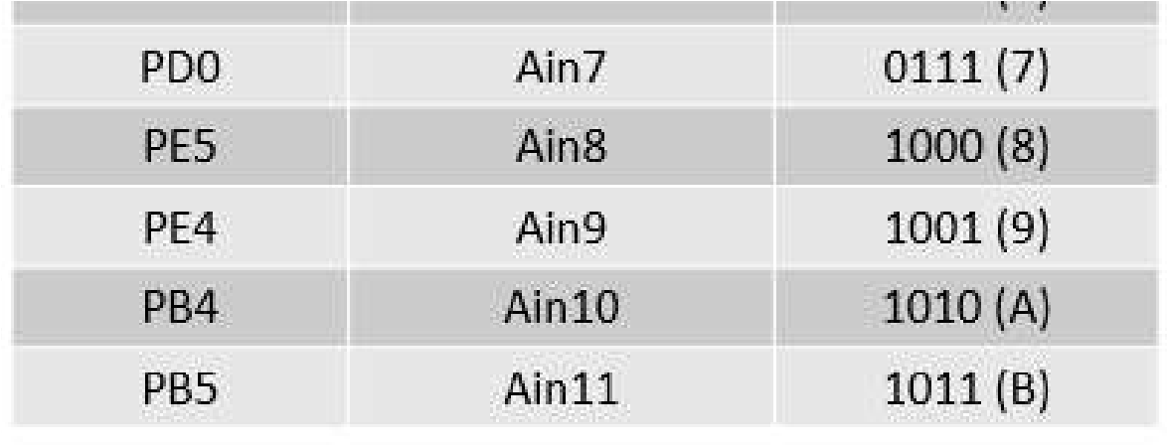

# SSCTLS:pg-873

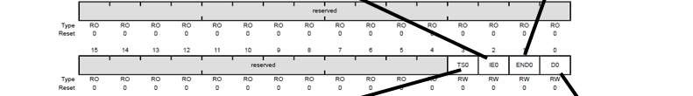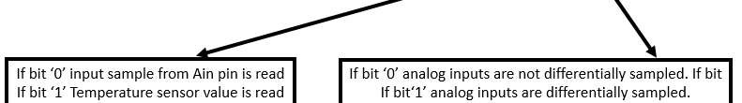

# PSSI:pg-842

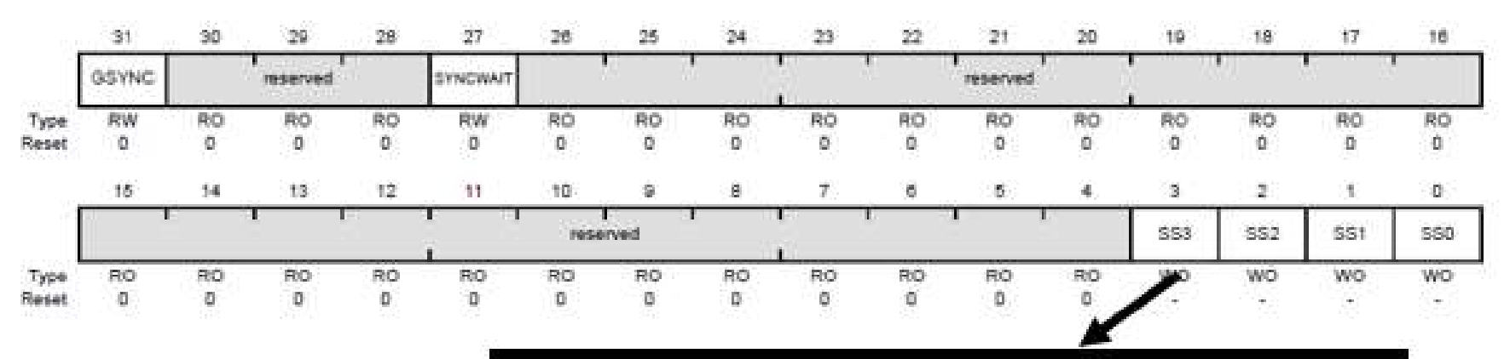

# RIS: and ISC:pg-820

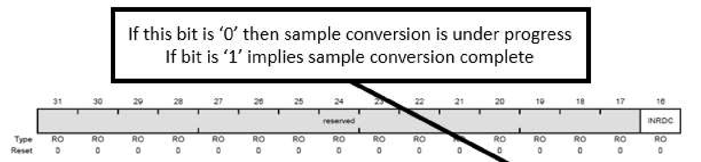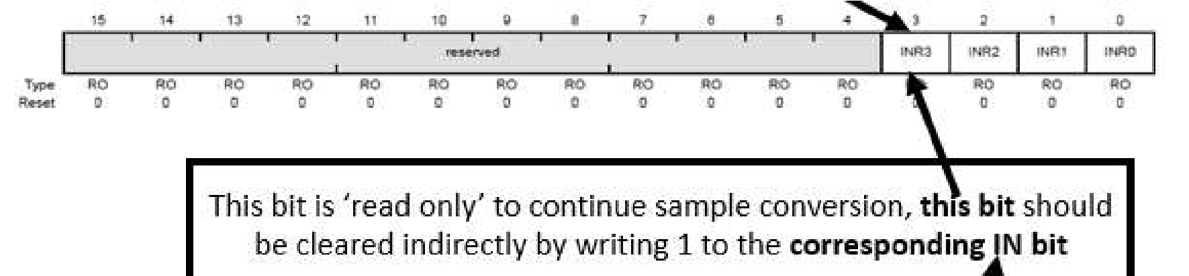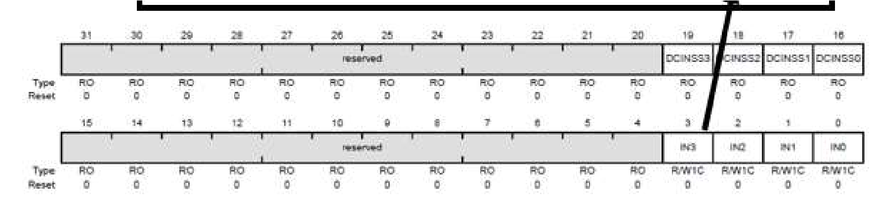

# SSFIFO:pg-857

